1000010 from base 2 to base 10

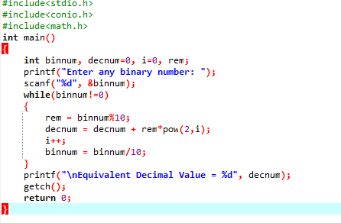

Output

